**Front-End UI/UX Mini Project**

**1. Title Page**

* **Project Title:** NGO Awareness Website
* **Submitted By:**
  + **Team Members:** Neha Tresa Boby

Tania Robby

* + **Roll Number(s):** 2460411

2461032

* + **College Email ID:** [neha.tresa@btech.christuniversity.in](mailto:neha.tresa@btech.christuniversity.in)

[tania.robby@btech.christuniversity.in](mailto:tania.robby@btech.christuniversity.in)

* **Course:** *UI/UX Design Fundamentals*
* **Instructor Name:** Mr. Narendra Kumar
* **Institution:** *Christ (Deemed to be University)*
* **Date of Submission:** 11/08/2025

**2. Abstract**

This project focuses on designing and developing a responsive and visually appealing NGO website aimed at promoting child welfare initiatives. The site’s primary goal is to raise awareness, encourage donations, recruit volunteers, and inspire adoption to support underprivileged children. Built using HTML for content structure and CSS for styling, the website integrates images, videos, CSS grid layouts, animations, and responsive design techniques to ensure accessibility across devices. It showcases the NGO’s mission, programs, gallery, and ways to get involved in an engaging manner. The final product is an intuitive, user-friendly platform that effectively communicates the organization’s values and impact, while making it easy for visitors to contribute through donations, volunteering, or adoption. This enhances community engagement and facilitates long-term support for children in need.

**3. Objectives**

* **Design a User-Friendly Interface**Create an engaging and intuitive website layout following modern UI/UX design principles to ensure easy navigation and clear information flow for all visitors.
* **Develop a Fully Responsive Layout**Build the website using only HTML and CSS, ensuring it adapts seamlessly to different screen sizes, from mobile devices to desktops.
* **Implement Structured HTML5 Semantic Elements**Use semantic tags such as <header>, <section>, <article>, and <footer> to organize content logically and enhance SEO and accessibility.
* **Apply CSS Styling for Branding, Layout, and Responsiveness**Incorporate consistent branding colours, typography, and styles while using CSS Grid, Flexbox, and media queries to ensure adaptive layouts.
* **Ensure Accessibility and Readability Across Devices**Optimize font sizes, contrasts, alt text for images, and keyboard navigation support to make the site usable for all, including people with disabilities.

**4. Scope of the Project**

The scope of this project is limited to the front-end design and development of an NGO website, focusing solely on the visual presentation and user interface. It does not involve any JavaScript functionality, backend programming, or server-side integration. All features and interactions are built using pure HTML5 and CSS3, without relying on external libraries or frameworks.

The design is fully responsive, ensuring optimal usability across desktop, tablet, and mobile viewports through adaptive layouts and media queries. Only open-source tools and manually written code have been used, ensuring originality and avoiding proprietary restrictions.

This project’s scope emphasizes creating an engaging, accessible, and visually appealing platform that effectively communicates the NGO’s mission while serving as a foundation for future enhancements, such as dynamic content and backend integration.

**5. Tools & Technologies Used**

| **Tool/Technology** | **Purpose** |
| --- | --- |
| HTML5 | Defines the website’s markup and organizes content structure using semantic elements for better accessibility and SEO. |
| CSS3 | Handles styling, layout design, responsive behaviour, animations, and visual branding of the website. |
| VS Code | Used as the primary code editor for writing, editing, and managing HTML and CSS files. |
| Chrome DevTools | Utilized for real-time testing, debugging, and optimizing the website’s layout and responsiveness across different devices. |

**6. HTML Structure Overview**

The website is built using semantic HTML5 tags to ensure clarity, accessibility, and searchengine optimization. Core semantic elements used include:

* **<header>** – Contains the NGO logo and a <nav> element with a <ul>-based navigation menu providing anchor links for smooth scrolling to different sections.
* **<main>** – Conceptually holds the primary content, structured into multiple <section> elements for different purposes:
  + **About Section** – Overview of the NGO’s mission and initiatives.
  + **Programs Section** – Descriptions of key welfare activities.
  + **Education Section** – Highlights the role of education.
  + **Gallery Section** – Showcases images in a slider format.
  + **Join Section** – Encourages volunteering, donations, and adoption.
* **<footer>** – Contains contact details, useful links, and a newsletter subscription form.

The structure is modular and reusable, allowing sections to be updated or rearranged easily. The navigation menu implemented with <ul> and <a> tags enable smooth, in-page scrolling between sections.

**7. CSS Styling Strategy**

The website’s styling is handled through an external CSS file (style.css), ensuring separation of concerns between content and presentation. The stylesheet is organized into commented sections for readability, covering areas such as common styles, section-specific designs, and responsive adjustments.

Key techniques applied include:

* **Flexbox and CSS Grid** – Used extensively for layout alignment, card arrangements, and program section grids, providing clean and adaptable structures.
* **Media Queries** – Implemented to ensure the site is fully responsive across desktop, tablet, and mobile viewports, adapting typography, spacing, and layout.
* **Hover Effects & Transitions** – Added for interactive elements such as buttons, cards, and images to improve user engagement.
* **Theme Customization** – Consistent branding colors (notably shades of red), typography, and spacing applied throughout; variables can be incorporated for easy updates.
* **Mobile-First Approach** – Designs tested and optimized starting from smaller screens upward to maintain performance and usability.

This approach ensures visual consistency, maintainability, and a seamless user experience across devices.

**8. Key Features**

| **Feature** | **Description** |
| --- | --- |
| Responsive Design | Fully adapts to various screen sizes, ensuring an optimal viewing experience on desktops, tablets, and mobile devices through CSS Grid, Flexbox, and media queries. |
| Smooth Navigation | Includes a fixed top navigation bar with anchor links for quick, smooth scrolling to different sections of the site. |
| Project Cards | Flexbox-based card layouts in the “Programs” and “About” sections, enhanced with hover effects and transitions for better interactivity. |
| Contact Form (Non-Functional) | A placeholder form layout included in the footer/newsletter section for user email input and subscription (no backend integration). |
| Accessible Fonts & Colors | Uses high-contrast color schemes, legible font sizes, and clean typography to maintain readability and accessibility across devices. |

**9. Challenges Faced & Solutions**

|  |  |  |  |  |  |  |  |  |
| --- | --- | --- | --- | --- | --- | --- | --- | --- |
| | **Challenge** | **Solution** | | --- | --- | | Overlapping elements on small screens | Implemented CSS media queries at various breakpoints (@media screen and (max-width: 1140px), 1024px, 768px, 425px, and 320px) to stack elements vertically, reduce image sizes, and adjust padding/margins for smaller devices. | | Difficulty aligning items using float | Abandoned float-based layouts in favor of Flexbox and CSS Grid, allowing more precise alignment, responsive rearrangement, and better control over spacing. | | Typography scaling issue | Switched from fixed pixel units to relative units (em, rem) for font sizes, ensuring text scales proportionately across devices and screen resolutions. | |

**10. Outcome**

The project successfully achieved a clean, consistent, and visually engaging front-end layout that effectively communicates the NGO’s mission and initiatives. All core components, such as the navigation menu, program cards, gallery, and responsive sections, function exactly as intended using only pure HTML5 and CSS3, without any JavaScript or backend integration.

Through the development process, a strong understanding of layout responsiveness, semantic HTML structure, and UI hierarchy was gained. The use of CSS Grid, Flexbox, and media queries ensured an adaptable design across desktop, tablet, and mobile devices.

The final product not only meets the design and functionality goals but also serves as a scalable foundation for future enhancements like dynamic content, form processing, and backend integration.

**11. Future Enhancements**

While the current version of the NGO website fulfils its front-end objectives using only HTML and CSS, several improvements can be implemented in the future to enhance functionality, user engagement, and overall experience:

1. Add JavaScript for Interactivity
   * Implement client-side form validation for the newsletter subscription and contact forms.
   * Introduce dynamic content loading to update sections without refreshing the page.
2. Integrate Animations and Transitions
   * Use CSS or JavaScript-based animations (e.g., GSAP, AOS) to create smooth section transitions, scroll effects, and interactive program or gallery displays.
3. Backend Integration for Form Submission
   * Connect forms to a backend (using PHP, Node.js, or similar) to process user submissions and store data in a database.
   * Enable email notifications for donations, volunteer sign-ups, or adoption inquiries.
4. Theme Toggler (Light/Dark Mode)
   * Implement a switch to allow users to toggle between light and dark themes, improving accessibility and personal preference compatibility.

These enhancements would transform the project from a static showcase into an interactive, data-driven platform, increasing its impact and usability.

**12. Sample Code**

* 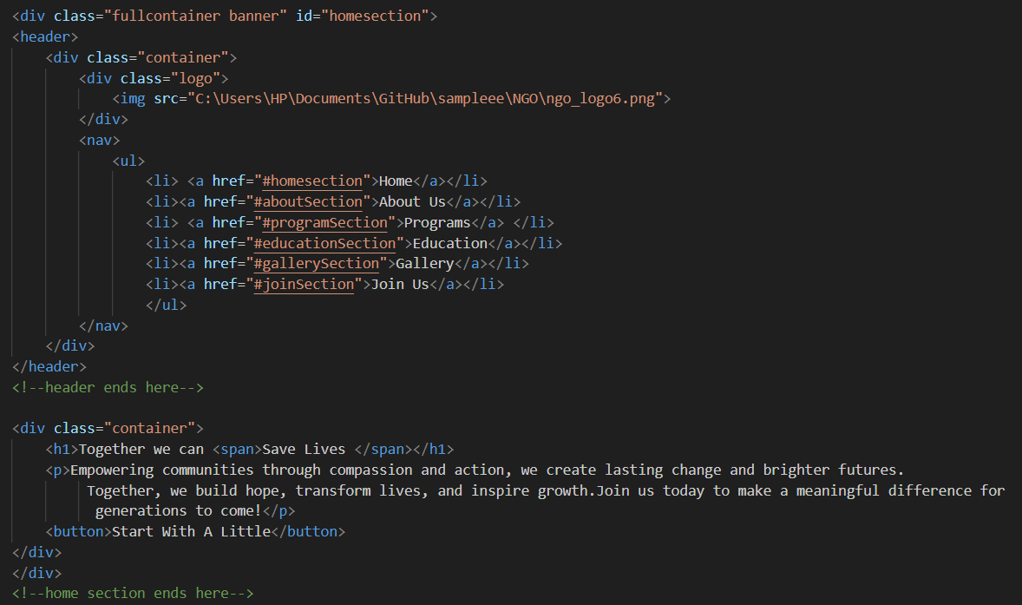**HTML – Navigation & Banner Section**
* **HTML – Programs Section (Card Layout)**

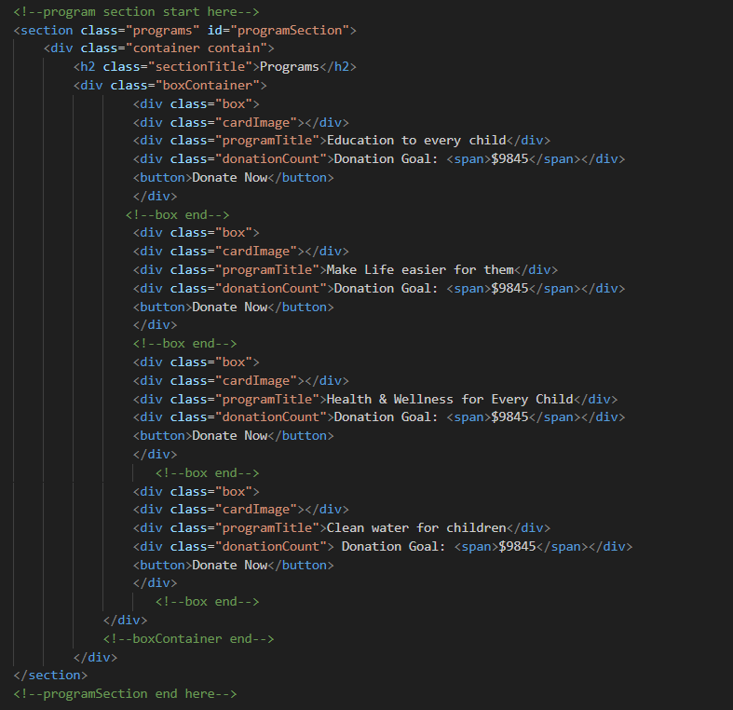

* 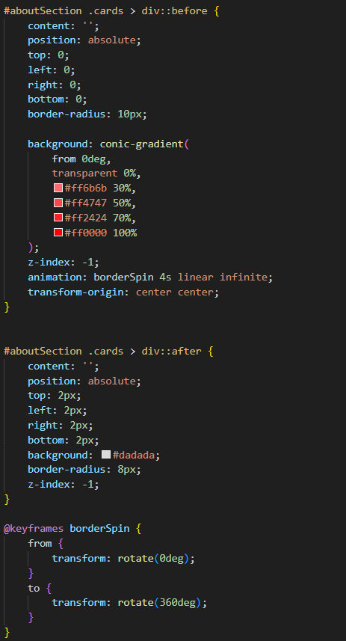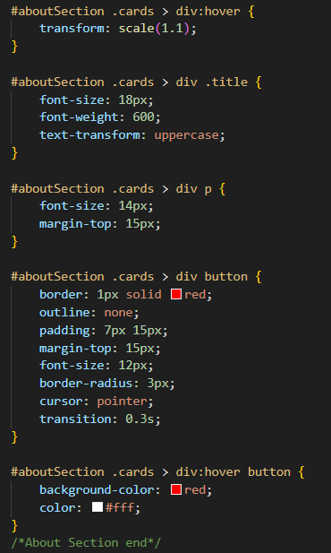**CSS – About Section (Animated Border Effect)**
* 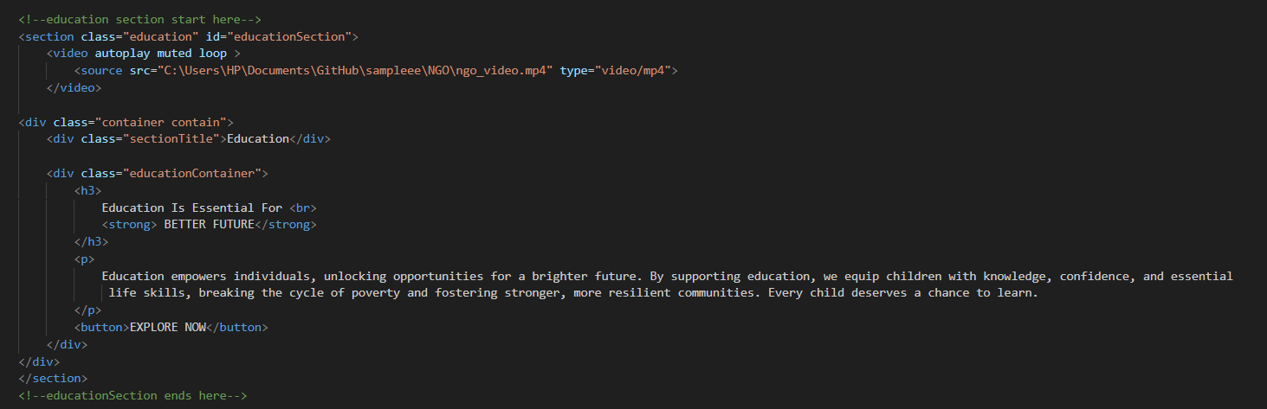**HTML – Education Section With A Background Video Player**
* **CSS – Gallery Section With Slider Effect**

